# Project Goals and Objectives

## Problem Definition

In this project, we aim design and produce a robot that can carry a long object, plank, through a maze collaboratively with another robot. Maze specifications is as follows.

* There are 5 streets maximum on the one side of the maze
* Street are 250 mm wide
* Maze walls are with 100 mm height
* Maze walls’ width is 10mm
* 10 mm from the top of the maze walls are painted with black, the rest is white.

After robots are connected each other with the plank, one of them will be chosen as master and the other slave. Master leads the way in the maze and slave robot follows master. The main problem in this project is “Handling the corners”. That is, in the case of U-turn, robots are not able to handle it at once. The whole procedure in such a case is given in the Figure XXXXXXXXXXXX.

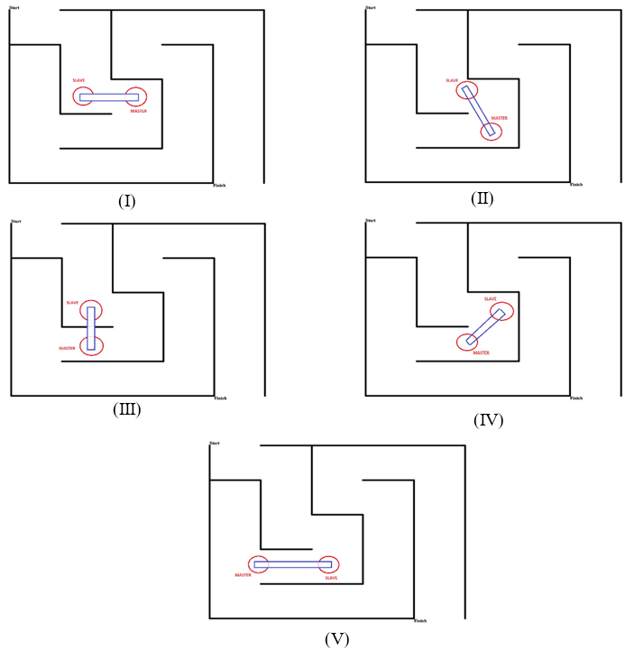

Figure XXXXXXXXXXXXXXXXXX: U-turn demonstration

Robots are not allowed to communicate each other directly. Thus, during the maze solving operation, our robot X-Cali performs *sensing*. Both active and passive sensing approaches are applied on X-Cali.

As X-Cali Group, our main aim is to design and produce a robot, is a solution for this maze problem, in in an efficient way. Efficiency is in terms of both software and hardware efficiency. Robustness is achieved firstly in the mechanical design period and it is improved with software. Additionally, we have taken to account aesthetic beauty as we bear commercial concerns. The robot is designed symmetrical manner so that its posture increases its sales appeal. Because of the commercial concerns, after sale services are also provided for this design.

## Objectives

### Company Objectives

* Improving theoretical and practical experiences
* Applying theory on practice
* Continuing in grow and being a corporate
* Overcoming the project
* Increasing the team skills: productivity and efficiency and time management
* Placing first in the contest at the very end of semester

### Project Objectives

* Minimalist and efficient design
* Considerably low power consumption
* Completing the maze without collision and damaging the other robot
* Keeping customer satisfaction high by providing high quality after sales services